


Computer Communications 26 (2003) 845–860

www.elsevier.com/locate/comcom

Quality of service provisioning through trafﬁc engineering with
applicability to IP-based production networks

Panos Trimintzios^{a,}*, Timothy Baugeґb, George Pavlouª, Paris Flegkasª, Richard Egan^{b}
aCentre for Communication Systems Research, University of Surrey, Guildford, Surrey, GU2 7XH, UK
bThales Research Ltd., Worton Drive, Reading, RG2 0SB, UK
Received 7 August 2002; accepted 7 August 2002

Abstract
Production networks require the transport of high-quality multimedia trafﬁc between outside broadcast vans and the main studio. This is
typically done through dedicated terrestrial or satellite links, with bandwidth purchased from third party network providers, which is
expensive and lacks ﬂexibility. Given the emergence of IP networks and the Internet as the multi-service network of choice, it is plausible to
consider their use for transporting production network trafﬁc with high bandwidth and low delay and packet loss requirements. Emerging
technologies for quality of service such as Differentiated Services and MPLS can be used for premium quality trafﬁc. In this paper we try to
use the emerging IP technologies to support services like production network trafﬁc. We present a Trafﬁc Engineering and Control System
that starts from agreed services with customers and provisions the network according to the expected trafﬁc demand so as to meet the
requirements of contracted services while optimising the use of network resources. We devise a non-linear programming formulation of the
problem and show through extensive simulations that we can achieve the objectives and meet the requirements of demanding production
network trafﬁc. Our solution is generic enough and not only tuned to production networks, so it can be used in other contexts for supporting
services with stringent quality of service requirements.
q 2002 Elsevier Science B.V. All rights reserved.
Keywords: Quality of service; Trafﬁc engineering; Differentiated services; Production networks

1. Introduction

Differentiated Services [1] is seen as the emerging
technology to support Quality of Service (QoS) in IP
backbone networks in a scalable fashion. Multi-Protocol
Label Switching (MPLS) [2] can be used as the underlying
technology to support Trafﬁc Engineering (TE). It is
possible to use these technologies to support production
network or other multimedia trafﬁc with stringent real-time
requirements. This can be done through careful trafﬁc
forecast based on contracted premium services with
customers and subsequent Network Provisioning (NP) in
terms of routing and resource management strategies.
Production network trafﬁc has very stringent require-
ments in terms of bandwidth, delay and loss. Today,
production networks use dedicated high-capacity network
infrastructures. These are inﬂexible and very expensive. In

* Corresponding author. Tel.: ю 44-1483-686005; fax: ю44-1483-
686001.
E-mail address: p.trimintzios@eim.surrey.ac.uk (P. Trimintzios).

this paper we show that it is feasible to support such
demanding trafﬁc requirements in a generic IP-based
network environment. This can be achieved by taking
advantage of the emerging IP technologies, Differentiated
Services (DiffServ) and MPLS, and through careful
provisioning and service management and control
decisions. Although the key motivation behind our work
is the support of production network trafﬁc, our ﬁndings are
generic enough and not only tuned to production networks,
so that they can be used in other contexts for supporting
services with stringent quality of service requirements.
This rest of this paper is organised as follows. Section 2
introduces production networks and their connectivity
requirements and Section 3 describes the related work. In
Section 4 we describe the QoS provisioning system for
supporting production network trafﬁc and describe its
operational cycle. Section 5 describes the NP algorithm
that is based on a non-linear programming formulation of
the problem. In Section 6 we provide the experimental
evaluation of our TE system through simulations. Finally, in
Section 7 we present our conclusions.

0140-3664/03/$ - see front matter q 2002 Elsevier Science B.V. All rights reserved.
PII: S 0 1 4 0 - 3 6 6 4 ( 0 2 ) 0 0 2 1 8 - 9

846

P. Trimintzios et al. / Computer Communications 26 (2003) 845–860

2. Packet-based production networks

Two types of studios are identiﬁed in production
networks: the Main Studio and Outside Broadcast (OB)
Vans. The main studio is where the ﬁlming takes place,
where the cameras, microphones, television monitors and
speakers are found. It accommodates the producer who
manages the personnel through talkback headset and
controls how the programme is put together. A storage
area is the part of the studio where audio, video and data
need to be stored, either short term for deferred broadcast or
long term for archiving. The second type of studios are the
OB Vans, which are mobile studios, taken to ﬁlm events
outside the main studio, such as races, concerts, sport
events, foreign correspondents, etc. They contain limited
production facilities, but enough to produce a broadcast
quality program from the range of cameras and microphones
deployed at the event. If the event is to be covered live, OB
vans can send the programme to the main studio in real time
via dedicated networks (satellite or terrestrial networks).
The production network audio and video trafﬁc is the
industry standards. For video the dominant standard is the
Serial Digital Interface (SDI). It produces 270 Mbps of
video with ancillary data for audio, metadata and time-
codes. The main standard for production audio (as opposed
to talkback which uses low quality audio channels) is AES3
(from the Audio Engineering Society). It can be transmitted
separately or embedded in SDI. AES3 contains two
channels, which can accommodate a stereo pair. The
transmission rate is 1536 Kbps.

2.1. Studio connectivity

The production network consists of all the video and
audio devices. They are divided into three separate
networks: the video network, the audio network and the
talkback network for the intercommunication trafﬁc.
Additionally, control and synchronisation signals must be
distributed across the site. For each network there is a
central studio router to which devices connect using
dedicated point-to-point links. The studio router is exclu-
sively designed to interconnect audio or video devices using
audio or video industry standards. Conﬁguring a studio for a
production session requires a signiﬁcant amount of work.
Audio, video, synchronisation and control connectivity
must be provided via separate cabling. Many devices use
proprietary protocols and cabling which increases the
complexity of interconnection.
Designing an IP network to replace the existing video,
audio, talkback and control networks inside a studio is not a
trivial task. Switched local area network technologies such
as Fast and Gigabit Ethernet can provide the required
capacity. However, the performance expectations placed on
the network require stringent quality of service guarantees.
This paper focuses only on the use of IP between studios
rather than inside them, the various approaches may be used

to provide adequate quality of service within the studio,
including over-provisioning and the use of the IP Integrated
Services framework.

2.2. Inter-studio connectivity requirements

Inter-studio connectivity is either studio to studio or OB
Van to studio. Connectivity may be through dedicated
terrestrial or satellite links, depending on availability and
economic factors, with bandwidth purchased from third
party network providers. Given the cost of such connec-
tivity, only one multimedia stream is sent from the van to
the main studio, possibly with talkback channels and control
signals if required. The latency on these links is orders of
magnitude higher than for intra-studio connections, but this
is acceptable as far as there are few feedback loops that use
the inter-studio link. In some cases such loops are
unavoidable, such as a speaker in the main studio
interviewing a foreign correspondent the other side of the
world. However, no control loops are required as each
studio (or OB Van) is autonomous. Bandwidth requirements
may also be relaxed by using compression.
The increasing availability of general purpose IP net-
works make them attractive candidates for interconnecting
studios and OB Vans. However, the issue of quality of
service over these networks must be successfully addressed
before they are seriously considered for this demanding
application. The current best effort paradigm is not
acceptable for real time video and audio transfer requiring
broadcast studio quality.
In order to provide adequate quality guarantees over an
IP Wide Area Network (WAN) that serves multimedia
production trafﬁc, we propose to use the DiffServ frame-
work together with MPLS for TE.
Fig. 1 shows a high level overview of the proposed
solution. We consider a studio and an OB van requiring to
exchange an SDI video ﬂow, a number of AES3 audio
streams, talkback trafﬁc and control signals. They are
connected over an IP WAN, which supports MPLS-TE and
DiffServ. As the sources and sinks send packets to the
WAN, routing protocols will determine paths across the
networks, usually based on a shortest path algorithm.
Conventional protocols do not take into account the load on
different parts of the network, which may lead to certain
areas of the network being congested while others under-
utilised. DiffServ selectively distributes resources among
the various classes of trafﬁc, which helps maintain quality
for selected trafﬁc aggregates but does not tackle the
congestion problem. In order to provide quality guarantees
while optimising the use of network resources, it may be
best to take a longer but less congested path through the
network [3]. This requires alternative methods of routing to
complement the operation of DiffServ.
This is achieved through TE, by explicitly routing trafﬁc
through the network using a set of calculated paths that
provide better control of the network load. Fig. 1 shows two

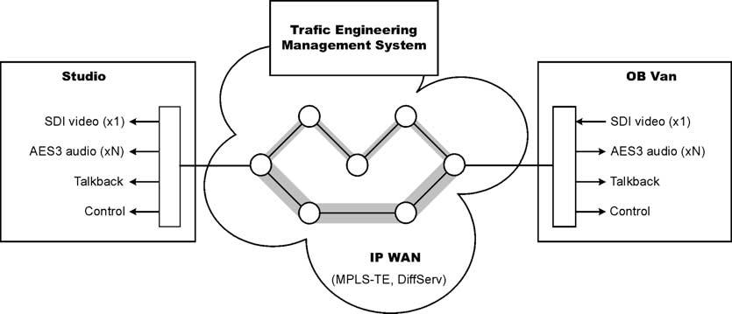

P. Trimintzios et al. / Computer Communications 26 (2003) 845–860

Fig. 1. Inter-studio connectivity over IP.

847

different paths between the OB Van and the studio, one
requiring 3 hops and the other 4. In this example, the
shortest path could be used to route the video stream, which
requires minimal delay, whereas the less critical talkback
trafﬁc would be kept separate and made to use the longer
path.
A trafﬁc engineering management system is used to
determine and enforce the trafﬁc engineered paths. Deter-
mining these paths in order to deliver the required quality of
service for the expected trafﬁc matrix is far from trivial. The
remainder of this paper focuses on the functionality, design
and evaluation of the proposed TE and QoS Delivery
Management System in the context of IP WANs that can
serve high-volume high-quality trafﬁc as required by IP-
based inter-studio production networks.

3. Related work

The problem of TE has attracted a lot of attention in recent
years. TE entails the aspect of network engineering that is
concerned with the design, provisioning, and tuning of
operational Internet networks. In order to deal with this
important emerging area, the Internet Engineering Task
Force (IETF) has chartered a Trafﬁc Engineering Working
Group (TE-WG) to deﬁne, develop, specify, and recommend
principles, techniques and mechanisms for TE in the Internet.
The main output of this working group until now is that it has
deﬁned the basic principles for TE [4] and the requirements
to support the interoperation of MPLS and Diffserv for TE
[5]. It is in the plans of this group to look into technical
solutions for meeting the requirements for Diffserv-aware
MPLS TE, the necessary protocol extensions, interoper-
ability proposals and measurement requirements.
Two similar works with the work presented in this paper
are Netscope [6] and RATES [7]. Both of them try to
automate the conﬁguration of the network in order to
maximize network utilisation. The ﬁrst one uses measure-
ments to derive the trafﬁc demands and then by employing
the ofﬂine algorithm described in Ref. [8] it tries to ofﬂoad
overloaded links. The latter uses the semi-online algorithm
described in Ref. [9] to ﬁnd the critical links which if they are
chosen for routing will cause the greatest interference (i.e.
reduce the maximum ﬂow) of the other egress – ingress pairs
of the network. Both of these works do not take into account
any QoS requirements and only try to minimize the
maximum load of certain links.
The work described in this paper can be categorised as
time-dependent ofﬂine trafﬁc engineering [4]. Such problems
can modelled as multi-commodity network ﬂow optimis-
ation problems [10]. The related works use optimisation
formulations, focusing on the use of linear cost functions,
usually the sum of bandwidth requirements, and in most of
the cases they try to optimise a single criterion, minimize
total network cost, or combine multiple criteria in a linear
formula.
In Mitra et al. [11] the TE problem is seen as a multi-
priority problem which is formulated as a multi-criterion
optimisation problem on a predeﬁned trafﬁc matrix. This
approach uses the notion of predeﬁned admissible routes,
which are speciﬁc for each QoS class, and each source –
destination pair, where the objective is the maximization of
the carried bandwidth. In Ref. [12], the authors address the
resource allocation and routing problem in the design of
Virtual Private networks (VPNs). The main objective is to
design VPNs which will have allocated bandwidth on the
links of the infrastructure network such that, when the trafﬁc
of a customer is optimally routed, a weighted aggregate
measure over the service provider’s infrastructure is
maximized, subject to the constraint that each VPN carries
a speciﬁed minimum. The weighted measure is the network
revenue, which is a function of the trafﬁc intensity. The
algorithm proposed in that paper solves ﬁrst the optimal
routing problem for each VPN independently. Then
calculates for each VPN the linear capacity costs for all the
links. These quantities are used to modify appropriately the
current capacity allocations so that the network revenue of
the infrastructure network for the new capacities is
maximized. In Ref. [12] it is shown that this is equivalent
to minimizing a linear function of the capacity costs subject
to constraints imposed by the link capacities.
In Ref. [13] a model is proposed for off-line centralized
TE over MPLS. This uses the following objectives: resource-
oriented or trafﬁc-oriented TE [4]. The resource-oriented

848

P. Trimintzios et al. / Computer Communications 26 (2003) 845–860

problem targets load balancing and minimization of resource
usage. Capacity usage is deﬁned as the total amount of
capacity used and load balancing is deﬁned as one minus the
maximal link utilization. The objective function that has to be
maximized is a linear combination of capacity usage and load
balancing, subject to constraints imposed by the capacity of
the links. The trafﬁc-oriented model suggests an objective
function that is a linear combination of fairness and
throughput, where throughput is deﬁned as the total
bandwidth guaranteed by the network and fairness as the
minimum weighted capacity allocated to a trafﬁc trunk. In
Ref. [14] the authors propose an algorithm which has two
phases, a pre-processing phase and an on-line one. In the pre-
processing phase the algorithm uses the notion of multi-
commodity ﬂows, where commodities correspond to trafﬁc
classes. The goal is to ﬁnd paths in the network to
accommodate as much trafﬁc as possible from the source to
the destination node. The algorithm tries to minimize a linear
cost function of the bandwidth assigned to each link for a
trafﬁc class. The second phase performs the on-line path
selection for LSP requests by using the pre-computed output
of the multi-commodity pre-processing phase.
Works like [8,15,16] try to achieve optimal routing
behaviour by appropriately conﬁguring the shortest path
routing metrics, assuming no MPLS is supported. Wang
et al. [15] proved theoretically that any routing conﬁgur-
ation, including the optimal one, could be achieved by the
appropriate setting of the shortest path routing metrics.
Finally, regarding online algorithms, they are mainly
based on extensions of the QoS-routing paradigm [17].
These approaches are heuristics, recently known in the IETF
as Constraint-Shortest Path First (CSPF), which utilise
information kept in TE databases populated through
information obtained from the routing ﬂooding mechanisms
about link capacities, unreserved capacity, colour afﬁnities
etc. Other online TE approaches [18,19] mainly focus on
load balancing on multiple equal or non-equal cost paths.
These works are complementary to work of this paper, since
they can be used in conjunction.

4. A provisioning system for QoS delivery and trafﬁc
engineering

This section presents the functional model that will
enable an Internet Service Provider (ISP) to conﬁgure and
provision its autonomous system (AS) in order to satisfy the
requirements of inter-studio production network trafﬁc. We
are focusing on deﬁning a time-dependent IP Trafﬁc
Engineering and Control System that operates at medium
(minutes to days) and long (weeks to months) timescales
[4].
We assume that customers¹will have bilateral Service
Level Agreements (SLAs) that contain both an adminis-

1 In this article we assume that a customer is an owner of a production
network as described in Section 2.

trative aspect (terms, conditions, pricing information, etc.)
and a technical part known as a Service Level Speciﬁcation
(SLS) [20]. Our system focuses to satisfy the SLSs of
quality-critical customers.
In the rest of the section, we will present the overall
proposed system architecture and we will elaborate on the
operational timescales. Fig. 2 shows the model of the
proposed system, which has evolved from our initial quality
of service framework described in Ref. [21], aspects of
which have also been developed further in Ref. [22].
The system in Fig. 2 is designed to provide an automated
mechanism to determine, implement and monitor network
conﬁgurations, which satisfy the following criteria:

1. Deliver the services as deﬁned in SLSs (customer
perspective),
2. Optimise the use of network resources (ISP perspec-
tive)

The above system is decomposed into three main sub-
systems: SLS management, TE and Monitoring. While the
main focus of this paper is on the TE part, we will also
brieﬂy describe the functionality of all the sub-systems for
completeness.
SLS management is responsible for SLS negotiation and
admission control. The negotiation and admission control
process by which SLSs are accepted or refused is outside the
scope of this paper. We assume that all existing SLSs, in the
SLS repository, have been admitted by an external process
and that no SLS will be added or deleted. Note though this is
not strictly true since new SLSs are typically added and
deleted in the system during its operation; these are only
taken into account by the TE system in the next provisioning
cycle. The basic production network SLSs we consider here
are described in Section 4.3. Trafﬁc forecast tries to predict
the anticipated trafﬁc demand based on the current
subscribed SLSs, policy-based over-provisioning factors,
and data both from SLS usage measurements and the history
of past predictions.
We monitor network performance in order to assess our
time-dependent periodic provisioning solution. Getting
monitoring feedback is very important for both time and
state-dependent [4] TE approaches, but only the latter uses
monitoring feedback to react to network conditions.
NP performs the main task of TE by periodically (i.e.
every provisioning period) running an ofﬂine algorithm
which computes the network conﬁguration in terms of
explicitly routed paths and capacity requirements for the
queues of each router; these are calculated according to the
forecasted demands. Route and resource managers are
responsible to apply the proper network conﬁguration for
every forecasting period. A route manager exists per ingress
router and sends explicit MPLS Labelled Switched Path
(LSP) set-up conﬁguration requests. LSPs are set-up
through a label distribution protocol, e.g. Constraint-based
routing label distribution protocol (CR-LDP) or the extended

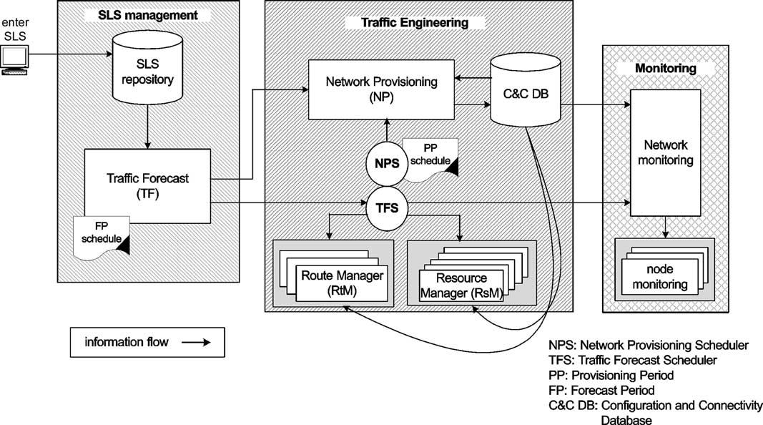

P. Trimintzios et al. / Computer Communications 26 (2003) 845–860

Fig. 2. Time-dependent IP TE and control system.

849

resource reservation protocol for TE (RSVP-TE). A
resource manager exists in every router and is responsible
for applying the conﬁguration of the DiffServ Per-Hop
Behaviours (PHBs) for all the router interfaces.

4.1. Provisioning and forecasting scheduling

In this section we will describe the timing and scheduling
properties of our system. We assume that scheduling in the
proposed model is performed at two levels:

† The NP Scheduler, which deﬁnes provisioning periods.
† The Trafﬁc Forecast Scheduler, which deﬁnes forecast-
ing periods.

4.1.1. Network provisioning scheduler
The IP Trafﬁc Engineering and Control System aims to
provision the network in order to provide the required QoS to
contracted SLSs while at the same time optimising the usage
of resources. As the trafﬁc requirements that are derived from
the SLSs change over time, the provisioning guidelines need
to be updated. This is performed periodically through the NP
Scheduler. The system is required to re-calculate a set of
provisioning guidelines for each provisioning period. As the
current period comes to an end, the Provisioning Scheduler
will trigger re-provisioning of the network. Typical frequen-
cies for the scheduler could be once a day or once a week.
The scheduler is part of the TE sub-system, and relies on
the provisioning period schedule; the latter provides the
frequency of the provisioning period.

4.1.2. Trafﬁc forecast scheduler
As the provisioning periods are quite long (days, weeks),
the trafﬁc requirements may vary during a provisioning

period. The granularity of the NP Scheduler is not ﬁne
enough to optimise the conﬁguration of the network. We
therefore use a second scheduler, the Trafﬁc Forecast
Scheduler, which has the following characteristics:

† It is not necessarily periodic (could schedule one 4 h
period followed by one 10 h period)
† For all forecasting periods FP(i ) that constitute a
provisioning period PP, it holds: FP(i ) # PP

The principle behind the double scheduling is that the NP
system is invoked once every provisioning period, and
calculates multiple conﬁgurations, which will be enforced at
each forecasting period. The various conﬁgurations are
successively applied at the appropriate times (triggered by
Trafﬁc Forecast Scheduler) by the Resource and Route
managers.
The Trafﬁc Forecast Scheduler is part of our TE sub-
system, which relies on the forecasting period schedule. The
latter deﬁnes the forecasting periods.

4.1.3. Scheduling example
To clarify the roles of each scheduler, this section
provides some examples.
Consider that provisioning period is a week and that
Trafﬁc Forecast Scheduler deﬁnes 4 – 6 h forecasting
periods (forecasting period being periodic in this case).
This means that once a week, four logical topologies are
calculated: one for the morning, one for the afternoon, one
for the evening and one for the night (6 h periods). During
each day of the week, Trafﬁc Forecast Scheduler triggers at
06:00 to enforce the morning conﬁguration, at 12:00 to
enforce the afternoon conﬁguration, at 18:00 to enforce the
evening conﬁguration and at 24:00 to enforce the night
conﬁguration. This is shown in Fig. 3.

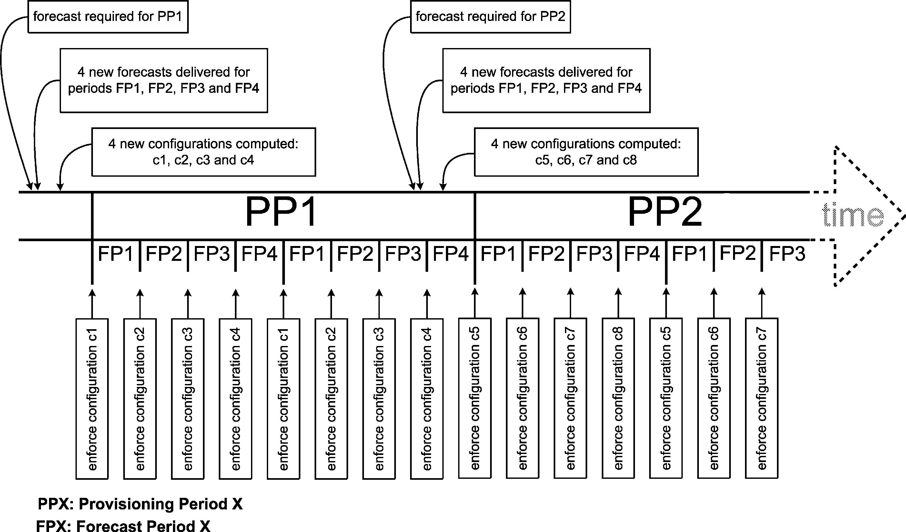

850

P. Trimintzios et al. / Computer Communications 26 (2003) 845–860

Fig. 3. Two level scheduling.

There is no requirement for Trafﬁc Forecast Scheduler to
be periodic. For example, we could have four forecasting
periods per day, morning, afternoon, evening and night with
different lengths as shown in Table 1.
Another more realistic and more complex example could
be to have ﬁve forecasting periods: weekday morning,
afternoon, evening, night, and all weekend. The interesting
feature of this arrangement is that the Trafﬁc Forecast
Scheduler does not trigger the enforcement of the
conﬁgurations in a simple cyclical fashion: the 4 weekday
conﬁgurations must be implemented cyclically for 5 days,
and the weekend conﬁguration is enforced for the remaining
two days of the week.

4.2. Operational cycle: a simple scenario

In order to illustrate the notions described above we will
walk through the sequence of events, which make up a full
operational cycle. Refer to Fig. 2 for the information ﬂow
described in this example. Fig. 4 shows a part of Fig. 3 in
detail, covering one provisioning cycle and the ﬁrst
conﬁguration enforcement.

4.2.1. Initialisation
There are two prerequisites for the operation of the
model. First, a number of SLSs have been agreed between
various customers (on behalf of users such as studios, OB
vans etc.) and the network operator. We assume that the
negotiation phase has taken place and the admitted/per-
mitted SLSs do not exceed the overall network capacity. No
SLS will be added after the initialisation phase. The SLSs
are entered into the SLS repository. Second, the network
topology (including the link capacities) exists in the
request. Then, the Trafﬁc Forecast Scheduler requests the
forecasting period schedule. It is important that the Trafﬁc
Forecast and Trafﬁc Forecast Scheduler have identical
views of the forecasting period schedule.

4.2.2. Operation
This scenario starts just before the beginning of a
provisioning period, at marker 1 in Fig. 4. The NP Scheduler
triggers NP to calculate a set of logical topologies for each
forecasting period of the forthcoming provisioning period.
In order to achieve this, NP requires the trafﬁc forecasts for
the given period, i.e. the forecasts for each forecasting
period in the next provisioning period.
In order to compute these forecasts, Trafﬁc Forecast
requests from the SLS repository a list of SLSs, which are
expected to be active during the next provisioning period.
Based on these SLSs, forecasts are generated, one for each
forecasting period, and are passed to NP (marker 2 in Fig. 4).
Trafﬁc Forecast requests the SLSs only after NP has
requested the forecast.
NP calculates a logical trafﬁc engineered topology for
each received forecast (i.e. forecasting period), so as to
provide the agreed QoS requirements while at the same time
optimising resource utilisation. These conﬁgurations are
stored in the C&C database (marker 3 in Fig. 4). NP
Scheduler is inactive until the next re-provisioning is due,
i.e. before the end of the next provisioning period.
The enforcement of the conﬁgurations is the responsi-
bility of Trafﬁc Forecast Scheduler. At the appropriate times
(i.e. at each forecasting period boundary), Trafﬁc Forecast

Table 1
Forecasting periods schedule example

Connectivity and Conﬁguration (C&C) database. The
topology will not be changed after the initialisation phase.
The C&C database makes the topology available to
Network Provisioning and Network Monitoring upon
Morning
Afternoon
Evening
Night
08:00 – 12:00
12:00 – 17:00
17:00 – 22:00
22:00 – 08:00

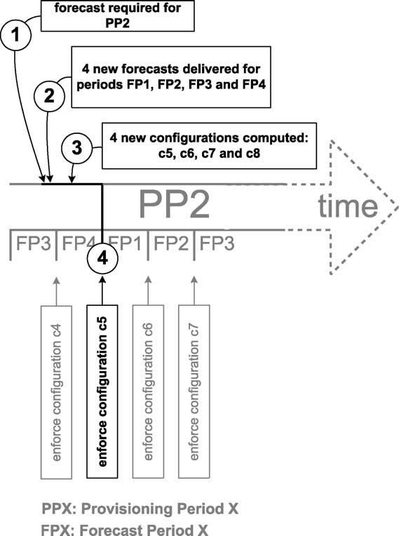

P. Trimintzios et al. / Computer Communications 26 (2003) 845–860

851

Fig. 4. Scheduling detail, re-provisioning and conﬁguration enforcement.

Scheduler triggers the enforcement of the new conﬁguration.
Marker 4 in Fig. 4 shows the Trafﬁc Forecast Scheduler
triggering the enforcement of conﬁguration ‘c5’. Route
Managers and Resource Managers enforce²the conﬁgur-
ation. The Route Manager focuses on provisioning the trafﬁc-
engineered paths, while the Resource Manager conﬁgures
the buffers and PHBs of the interfaces of each network node.
Here we assume that the implementation of the PHBs on the
various interfaces allows conﬁguration, by deﬁning an upper
limit on the buffer, and by either setting the relative weight
(Weighted Fair Queuing-WFQ) and/or the relative priority
(Class-Based Queuing or Priority Queuing).
The Trafﬁc Forecast Scheduler also causes monitoring to
retrieve the new logical topology information in order to
monitor the performance of the current network
conﬁguration.

4.3. From SLSs to classes of service

SLS management in the context of this paper is
responsible for providing trafﬁc forecasts to the NP. The
forecasts are based on the following information:

2 Note that a very important operational consideration has to do with the
transition from one conﬁguration to another with the minimal disruption to
the network and the current trafﬁc. This issue, though very important, is
outside the scope of this article, but a simple way out could be to apply the
new conﬁguration at the same time with the old. Then wait for all the
already established ﬂows of old conﬁguration to drain before tearing it
down, while at the same time all the new trafﬁc demand is directed through
the new conﬁguration.

† SLSs negotiated between the customers and network
operator.
† Policy data set by the operator, including the forecasting
period schedule.
† Measurements and historical data.

The SLS repository is a passive database. In this work we
assume no negotiation or admission control procedure and
the SLSs are entered through a user interface. The SLSs are
indexed by start and end time. We are considering the
following SLS types: video (SDI or compressed), audio
(AES3 or compressed), which both have stringent delay and
loss requirements, and production network control trafﬁc
which has less strict delay and certainly smaller throughput
requirements. Note that for performance assessment pur-
poses we also assume some background trafﬁc SLSs, for
different kinds of trafﬁc than the studio production network
types described above.

4.3.1. Trafﬁc forecast
The role of the Trafﬁc Forecast is to estimate the
anticipated trafﬁc for each forecasting period. The forecast-
ing periods are determined based on the forecasting period
schedule. For each forecasting period, four successive
functions are performed: translation, mapping, aggregation,
and forecasting.
Translation. The Customer SLSs stored in the repository
use a customer-orientated terminology. These SLSs have
the following semantics. They are the either bi-directional
or unidirectional and follow either the pipe or the VPN
model. The ﬁrst function of translation is to decompose
these SLSs into a number of simple unidirectional SLSs,
which follow only the pipe model (one ingress to one
egress). The ingress and egress are speciﬁed in geographical
terms, therefore there is a need to translate those into IP
source – destination addresses and from them to infer the
speciﬁc ingress – egress addresses of our Autonomous
System (AS). Services are given names (Olympic Gold/-
Silver/Bronze Service, Virtual Leased Line). This terminol-
ogy must use networking semantics (throughput, delay,
loss). So, another important aspect of translation is from the
customer SLS to the appropriate network parameters.
Mapping. The simple unidirectional SLSs could poten-
tially request (or be translated to) any value of delay, loss or
throughput, while the network supports only a few discrete
values. The mapping function is therefore to map the SLS
requirements to the services actually supported by the
network, i.e. the Classes of Service (CoS). Another
important function is to map the IP source – destination
addresses. To illustrate the mapping function, consider the
following simple example. A customer SLS may require
‘1 Mbps of Virtual Leased Line Premium service with
50 ms delay between London and Manchester,…’. The
translation function would translate this Customer SLS into
to two simple unidirectional SLSs: ‘1 Mbps, EF, 50 ms
delay, from 122.12.2.143, egress 103.124.32.111,…’ and

852

Table 2

P. Trimintzios et al. / Computer Communications 26 (2003) 845–860

Deﬁnitions of class of service and trafﬁc trunk
Class of service (CoS) PHB scheduling class (PSC)

Delay range

Loss probability range

Trafﬁc Trunk

Ingress IP address

Egress IP address

CoS

Throughput requirement

another one with the same values but in the opposite
direction. Suppose the network offers two services: a 10 and
100 ms delay premium virtual wire services, therefore we
need to map the SLS to the 10 ms service. The mapping is
static as far as the mapping algorithms are ﬁxed and
deterministic. The result is a list of SLSs that are active
during the next provisioning period and are deﬁned in
network terms.
Aggregation. Up to this point of the forecasting
procedures we had information proportional to the number
of customers and SLSs. For scalability, we base our TE
solution on trafﬁc loads per ingress/egress pair and per class
of service (see Section 2). We use the concept of trafﬁc
trunk [23], which is deﬁned by the ingress/egress node pair,
the class of service and the capacity requirement (Table 2).
The simple unidirectional SLSs are aggregated into trafﬁc
trunks by ‘adding’ their throughput requirements if and only
if they have the same ingress/egress pair and they require a
similar treatment, i.e. they have the same CoS values. We
deﬁne the distinct CoS to be uniquely identiﬁed by the
required PHB Scheduling Class [24], a delay range and loss
probability range (Table 2).³SLSs may be multiplexed. If
two clients require the same service but at different times
within a forecasting period, they are multiplexed in the
trafﬁc forecast. Note that multiplexing may occur within a
class of service, but not between classes.
Forecasting has two main functions. On one hand, an
over-subscription factor per CoS is included. This factor is
deﬁned as the ratio of the capacity reserved by all the SLSs
in a given CoS to the capacity expected to be actually used.
For expensive SLS types, the over-subscription factor is
likely to be one. For cheaper services, the factor may be
larger. On the other hand, at this stage we have all the
ingress – egress demand (trafﬁc matrix). It is possible to run
an extrapolation algorithm utilising the information on the
history of trafﬁc matrices. Candidate algorithms are the
spline or more generally any polynomial extrapolation
method.

5. A trafﬁc engineering solution

Network Provisioning is the main module of our TE
system (Fig. 2). It provides guidelines for provisioning the
network according to trafﬁc estimates and resource
utilisation policies (see Section 4.3.1).

3 Normally a SLS and consequently a CoS will have a delay variation
(jitter) parameter, but since our current TE solution does not take it into
account (Section 5) we are omitting it from the table.

The objectives are both trafﬁc and resource-oriented. The
former relate to the obligation towards customers, through
the SLSs. These obligations induce a number of restrictions
about the treatment of trafﬁc. The resource-oriented
objectives are related to the network operation, more
speciﬁcally they are results of the high-level business policy
that dictates the network should be used in an optimal
fashion. Congestion is the main cause of network perform-
ance degradation that inﬂuences both these TE objectives.
Two are the main reasons behind congestion: either the
demand exceeds the network capacity, or the trafﬁc is not
spread optimally, causing parts of the network to be over-
utilised while others are under-utilised. The ﬁrst reason can
only be handled by adequate network planning, i.e. adding
more physical resources. The latter can be handled by
adequate bandwidth and routing management, and this is
what NP is aiming for.
NP has as input the network topology (including link
capacities), the estimated trafﬁc matrix (expected trafﬁc
trunks, see Section 4.3.1), and resource-oriented policy
directives⁴. It will provide as an output a list of explicitly
routed paths for each source destination included in the
trafﬁc matrix, and the capacity requirements for each PHB
scheduling class, and therefore physical queue [24] for
every interface of all the network nodes.

5.1. Network and trafﬁc model

The network is modelled as a directed graph G ј рV ; EЮ;
where V is a set of nodes and E a set of links. Each link l [ E
is speciﬁed by the pair l ј рv_{l};i;v_{l};e^{Ю}where v_{l};i;v_{l};e are the
nodes where trafﬁc is entering and exiting the link,
respectively.
With each link l [ E we associate the following
parameters: the link physical capacity C_{l}, the link
propagation delay d_{l}prop;the set of the physical queues H,
i.e. PHB Scheduling Classes (PSCs), supported by the link.
For each PSC, h [ H we associate a bound d^{h}l (deterministic
or probabilistic depending on the PSC) on the maximum
delay incurred by trafﬁc entering link l and belonging to the
h [ H, and a loss probability p^{h}l of the trafﬁc entering link l
and belonging to h [ H.
The basic trafﬁc model of NP is the trafﬁc trunk. A trafﬁc
trunk is an aggregation of a set of trafﬁc ﬂows characterised
by similar end-to-end performance requirements [3]. Also,
each trafﬁc trunk is associated with one ingress node and
one egress node, and is unidirectional. Each trunk

4 In this work we do not consider the way policies inﬂuence our system.
For a comprehensive discussion of policies in this context see Ref. [25].

P. Trimintzios et al. / Computer Communications 26 (2003) 845–860

853

corresponds to a CoS as deﬁned in the context of this paper
(see Section 4.3.1). The set of all trafﬁc trunks is denoted by
T. Each trunk t [ T, from ingress node v_{i}to egress node v_{e}
(v_{i}; v_{e}[ V ), is associated with a bandwidth requirement, B_{t}:
The following information about each trafﬁc trunk is
available because of the CoS deﬁnition (see Table 2):

† The PHB Scheduling Class (PSC) of the trafﬁc carried on
the trunk, thus inferring the PHB h [ H of the trunk. For
certain PSCs (e.g. AF1x) the mapping to PHB is not ‘1 –
1’, providing more ﬂexibility. This means that each
trafﬁc trunk t [ T is associated (eventually) with one
PHB.
† The bound D_{t}(deterministic or probabilistic depending
on the PSC) maximum end-to-end delay expected
between the ingress and egress nodes. This might be
the minimum value of the delay class range of the CoS
deﬁnition.
† The maximum end-to-end loss probability, P_{t}required
between the ingress and egress nodes. Similarly to the
previous case this might be the minimum value of the

has to be quantiﬁed. Various deﬁnitions are possible. In
general, the load (or cost) on a given link is an
increasing function of the amount of trafﬁc the link
carries. This function may refer to link utilization or may
express an average delay, or loss probability on the link.
In the context of this work, the QoS seen by the trafﬁc
using the different PHBs varies, so the link load induced
by the trafﬁc of each PHB may vary. This leads us to the
following general form of the cost of link l.
Let x^{h}l denote the capacity demand (ﬂow) for PHB h [ H
satisﬁed by link l. Then the link cost induced by the load on
PSC h [ H is a convex function, f_{l}h_{р}x^{h}l^{Ю}; increasing in x^{h}l:
The total link cost per link is deﬁned as:
X
F_{l}рx_{l}Ю ј f_{l}h_{р}x^{h}l^{Ю}р1Ю
h[H
where x_{I}ј {x^{h}l}h[H is the vector of demands for all PHBs
of link l. In order to take into account that link capacities
may be different, the cost may be modiﬁed to reﬂect
equivalent utilization as follows:
X

loss range of the CoS deﬁnition.
† The bandwidth B_{t}requirements.
F_{l}рx_{l}Ю ј
h[H
f_{l}h_{р}x^{h}l^{Ю}
C_{l}
р2Ю

5.2. Cost deﬁnition and optimisation objectives

We need to provide a set of routes for each trafﬁc trunk.
For each ingress – egress pair v_{i}; v_{e}these routes are
implemented as LSPs at the routers. We also need to
provide the amount of bandwidth each route is expected to
carry, and the amount of bandwidth that is to be allocated
to the PSCs at the various interfaces in the network.
The primary objective of such an allocation is to
ensure that the requirements of each trafﬁc trunk are met
as long as the trafﬁc carried by each trunk is at its
speciﬁed minimum bandwidth. This objective ensures
that our SLS requirements are met. The objective is to
provide a feasible solution (i.e. routes and route
bandwidths respecting the link capacities) that satisﬁes
the SLSs delay and loss constraints.
However, with the possible exception of heavily loaded
conditions, there will generally be multiple feasible
solutions. Hence, the design objectives can be further
reﬁned to incorporate other requirements such as:

1. Avoid overloading parts of the network while other parts
are underloaded. This way, spare bandwidth is available
at various parts of the network to accommodate
Provided that appropriate buffers have been provided at
each router and the scheduling policy has been deﬁned,
then f_{l}h_{р}x^{h}l^{Ю}may specify the equivalent capacity needed
by PHB h [ H on link l in order to satisfy the loss
probability associated with that PHB. Hence, the total
cost per link is the total equivalent capacity allocated on
link l. Note that with this approach the link costs are
very naturally deﬁned. The drawbacks are: (1) the cost
deﬁnition depends on the PHB implementation at the
routers, (2) the cost functions may not be known, or may
be too complex. Hence approximate cost functions must
be used.
In this work we are using the following cost function:
xh
f_{l}h_{р}x^{h}l^{Ю ј}l р3Ю
C_{l}2 x^{h}l
This function combined with Eq. (1), gives as a total cost
function the average number of packets in the system
based on the hypothesis that each queue behaves as a M/
M/1 queue [26].
Now we can express objectives (a) and (b) in
mathematical terms.
Avoid overloading parts of the network:

unpredictable trafﬁc requests. In addition, in case of
X
.
!

link failures, smaller amounts of trafﬁc will be disrupted
and will need to be rerouted.
minimise max F_{l}рx_{l}Ю ј max
l[E l[E
h[H
f_{l}h_{р}x^{h}l^{Ю}C_{l}
р4Ю

2. Provide overall low network load (cost).

The last two requirements do not lead to the same
Minimize overall network utilization:

.

!

optimisation objective. In any case, in order to make the
last two requirements more concrete, the notion of ‘load’
minimise
X X
F_{l}рx_{l}Ю ј
l[E l[E
X
h[H
f_{l}h_{р}x^{h}l^{Ю}C_{l}
р5Ю

854

P. Trimintzios et al. / Computer Communications 26 (2003) 845–860

It is possible to provide an objective that compromises
between the previous two. More speciﬁcally,
!_{n}

as follows:

X
minimise

X

f_{l}h_{р}x^{h}l^{Ю}=C_{l}

!_{n}

р7Ю

minimise
X_{р}F_{l}рx_{l}ЮЮ^{n}ј^{X}
l[E l[E
X
h[H
f_{l}h_{р}x^{h}l^{Ю}=C_{l}
; n $ 1 р6Ю
l[E

subject to:
h[H

When n ј 1, this objective Eq. (6) reduces to Eq. (5), while
X

; K_{P}}; ;r_{t}[ R_{t}

р8Ю

when n ! 1 it can be shown that it reduces to Eq. (4). The
exponent n is important for the results presented in Section
l[r_{t}
1 # min{K_{D}
t
t

6. By using Eq. (6), even if we are using the linear cost
function for f_{l}h_{р}x^{h}l^{Ю}; the problem becomes a non-linear
optimisation problem.
X
r_{t}[R_{t}
b_{r}t^{ј}B_{t}; ;t [ T
р9Ю

5.3. Handling the delay and loss constraints
x^{h}l^{ј}
X
X
b_{r}t;
;l [ E; ;h [ H

р10Ю

Each trafﬁc trunk is associated with an end-to-end delay
D_{t}and loss probability P_{t}, constraint of the trafﬁc belonging
to the trunk. Hence, the trunk routes must be designed so
t[T:h_{t}јh r_{t}:l[r_{t};r_{t}[R_{t}

b_{r}t$0; ;r_{t}[ R_{t}; ;t [ T

р11Ю

that these two QoS constraints are satisﬁed.
Given the trafﬁc trunks’ route r ј {l₁; l₂; …; l_{k}}; the end-
to-end delay is bounded by the sum of the propagation
delays and the per node delay over the route. The same
holds for the end-to-end loss probability. Let d^{h}l be the
bound on the maximum delay on the link l associated with
PHB h, dprop h
l is the propagation delay, and p_{l}is the
maximum loss probability of that link.
Both the constraints above are constraints on additive
path costs under speciﬁc link costs (d^{h}l^{and}p^{h}l;respectively).
However, the problem of ﬁnding routes satisfying these
constraints is in general NP-complete [27]. Given that this is
only part of the problem we need to address, the problem in
its generality is rather complex. Fortunately, a reasonable
simpliﬁcation can be made.
Usually, loss probabilities and delay for the same PHB on
different nodes (routers) are of similar order. Therefore we
use the maximum delay, d_{max}h_{ј}max_{l}[E{d_{l}h} and maximum
loss probability, p^{h}max^{ј}max_{l}[E{p^{h}l } of a particular PHB
over the whole network, in order to translate the delay and
loss constraints to an upper bound on the number of hops
along a route. For each trafﬁc trunk t [ T, let K_{D}denote the
Eq. (7) provides the optimisation objective, where n is a
variable that provides the relative merit of low overall cost
and avoid overloading parts of the network. In Eq. (8) we
add the hop-count constraint, which (see Section 5.3) is
deduced from the delay and loss QoS requirements of the
SLSs. Eq. (9) states that the bandwidth of the explicit routes
per trafﬁc trunk should be equal to the trunks’ capacity
requirements, and Eq. (11) ties the optimisation objective
with the optimisation parameters.
In the formulation above (Eqs. (7) – (11)), we have not
included any constraint for the physical link capacity. We
handle this by deﬁning the cost function Eq. (3) to increase
very fast when the total link ﬂow becomes greater than the
physical link capacity, for example exponentially or
polynomially to utilisation x^{h}l⁼C_{l}; which in this case will
be greater than one. This will avoid getting over the link
capacity. Special care is required since the cost function and
its ﬁrst derivative need to be continuous at the point of
change.
This is a network ﬂow problem and considering the non-
linear formulation described above, the optimal solution can
based on the general gradient projection method [28]. This

t
upper bound on the number of hops induced from the delay
constraint, and K_{P}t the upper bound because of the loss
probability constraint. It should be noted that since loss
probabilities per PHB are generally small relative to the
end-to-end loss probability, the resulting bound in this case
will be large and hence it will not have a big effect on the
optimisation. In any case, the resulting constraint is now
simpler.

5.4. Optimisation problem formulation

For each trafﬁc trunk t [ T we denote as R_{t}the set of
(explicit) routes deﬁned to serve this trunk. For each r_{t}[ R_{t}
we denote as b_{r}the capacity we have assigned to this
is an iterative method, where we start from an initial feasible
solution, and at each step we ﬁnd the minimum ﬁrst
derivative of the cost function path and we shift part of the
ﬂow from the other paths to the new path, so that we
improve our objective function (Eq. (7)).
If the path ﬂow becomes negative, the path ﬂow simply
becomes 0 (max {0,x}) in order to handle the non-negativity
constraint Eq. (11). This method is based on the classic
unconstraint non-linear optimisation theory, and the general
point is that we try to decrease the cost function through
incremental changes in the path ﬂows.
The optimisation variables are the capacity variables b_{r}t
assigned to each route of each trunk, i.e. b ј {b_{r}t:r_{t}[
R_{t}; t [ T }: In order to apply the gradient projection method

t
explicit route. The optimisation problem can be deﬁned now
we need to handle all the constraints. Substituting Eq. (10)

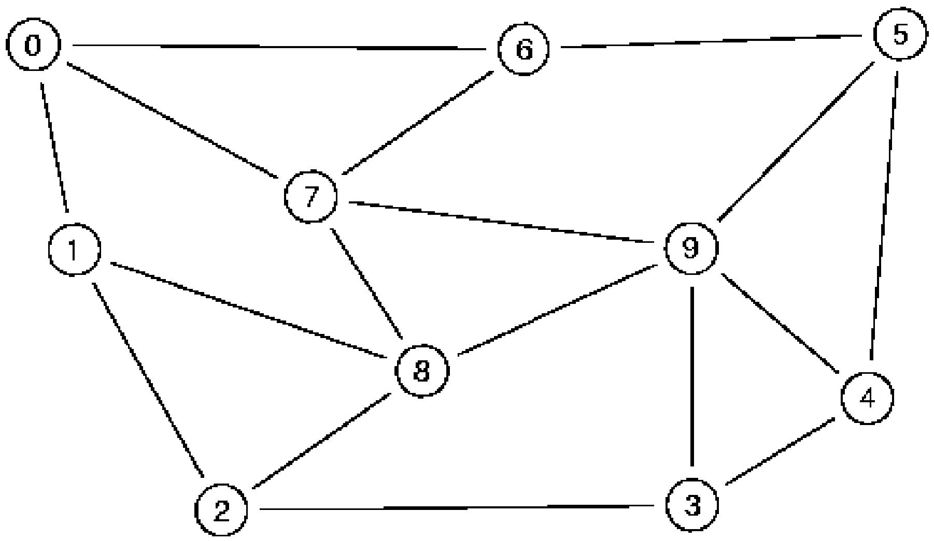

P. Trimintzios et al. / Computer Communications 26 (2003) 845–860

in the optimisation function Eq. (7), we get: 6.1. Topologies
0 0 1 1_{n}

855

FрbЮ ј
X
@
X
f_{l}h@
X
X
b_{r}t^{A}=C_{l}A
р12Ю
When evaluating a system like the one proposed in this

l[E
h[H
t[T:h_{t}јh; r_{t}:l[r_{t};r_{t}[R_{t}
paper, care is required regarding the simulation conditions,
including the topologies used, the trafﬁc demand generation

The constraint Eq. (9) states that the capacity assigned to
each variable b_{r}t should be equal to the trunks’ capacity
procedure and the intensity of the expected load.

requirements, i.e.^{P}r
t[R_{t}
b
r_{t}ј B_{t}; ;t [ T : We can handle
The main topology used is shown on Fig. 5; it has 10
nodes and 34 unidirectional links. This is a rather small

this by substituting at each iteration i and for each of the
trunks ;t [ T, one of the variables b_{r}t^{r}t[R_{t}, say b_{r}t;is
substituted by
X
topology that resembles the early NSFNet backbone. More
complex and bigger topologies (up to 300 nodes) where also
used, according to the widely used models for random

b_{r}t^{ј}B_{t}2

r_{t}[R_{t}2{r_{t}}
b_{r}t
р13Ю
topology generation presented in Ref. [31]. We used both
random and transit-stub networks, which represent the AS
system hierarchical structure better than pure random. The

The hop-count constraint Eq. (8) can be handled as
follows. At each step of the algorithm we are required to ﬁnd
a minimum weight path for each trunk t [ T with the
weights being the ﬁrst derivative of the cost function
topologies used were of 50, 100, 200 and 300 nodes with
average node degree between 3 and 6 (bi-directional), which
are close to the typical values for real networks. In general,
for the results we opted for 90% conﬁdence level with a

›FрbЮ
ј^{X}
h
i
conﬁdence interval 8 – 10% of the corresponding values.

db_{r}t^{ј}
›b_{r}t
"
l[r_{t}
nрF_{l}рx_{l}ЮЮ^{n}21_{р}F_{l}рx_{l}ЮЮ⁰
!_{n}21

#

6.2. Initial conditions

ј^{X}
l[r_{t}
n
C | n  l
X
h[H
f_{l}h_{р}x^{h}l^{Ю}
d
dx^{h}l
рf_{l}h_{р}x^{h}l^{ЮЮ}
р14Ю

The initial feasible solution (step 0) of the iterative

this db_{r}t is the minimum ﬁrst derivative length path, which
should be included in the optimum solution. In order to
consider the hop-count constraint, the minimum weight path
computation algorithm has to check whether the path found
satisﬁes the hop-count constraint as well. If not, then we
need to ﬁnd another path (not necessarily with the minimum
weight but with a total weight less than at least one of the
paths in R_{t}), which has hop-count, at least the hop-count
constraint. This procedure is done by either using a k-
shortest path algorithm [29], or by re-trying a simple
shortest path, e.g. Dijkstra’s [30], on a reduced graph.
We need to have a way to control the procedure
described above. We will accept a solution if the relative
improvement in a step i ю 1 from step i, is less than a
parameter e. More speciﬁcally the iterative procedure
terminates when the following equation becomes true,
Fрb^{i}ю1_{Ю}2 Fрb^{i}Ю
, e р15Ю
procedure described in Section 5.4 is set to be the same as if
the trafﬁc trunks were to be routed with a shortest path ﬁrst
(SPF) algorithm. That corresponds to the case that all the
trafﬁc of a particular class from ingress to an egress will be
routed through the same shortest path according to some
weight (routing metric). If there exist more than one such
shortest paths, the load is distributed equally among them.
The metric we are using for the SPF algorithm is set to be
inversely proportional to the physical link capacity. The
scenario we are using for step 0 described above is the norm
in today’s operational networks.
The experiments shown in this section correspond to only
one forecasting period, i.e. one run of the provisioning
algorithm. It is straightforward to get results for the
provisioning period by concatenating more than one
forecasting period results. The termination parameter e,
see (Eq. (15)), is set equal to 0.0008.

Fрb^{i}ю1_{Ю}

6. Experimental evaluation

In this section we will investigate the performance of the
system described in Section 5 in terms of long to medium
term average link load and total network average delay.
The NP algorithm described in Section 5 was
implemented in ANSI C and a random SLS/Forecast
generator in Java (see later). For the experimental results
presented in the section we used a 2 Ј 450 Mhz ULTRA
SPARC II with 1024 MB memory running Solaris 7.

Fig. 5. Fixed topology used for experimentation.

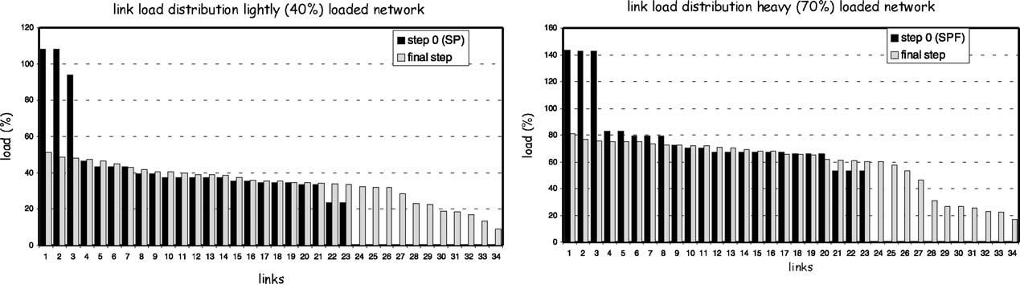

856

Table 3
Loading proﬁles for each SLS type
SLS type

P. Trimintzios et al. / Computer Communications 26 (2003) 845–860

with this procedure, resulting in one matrix for each SLS ﬁle
for each loading proﬁle.

6.4. Simulation results

Video (%) Audio (%) Control trafﬁc (%)

Fig. 6 shows the link loads for the 10-node topology

Medium load 40% 30
High load 70% 50

6.3. Trafﬁc load generation
9
18
1
2
shown in Fig. 5 for the ﬁrst step and after the algorithm has
run. It is clear that at step 0 solution, which corresponds to
the SPF with equal cost multi-path distribution enabled,
parts of the network are over utilised while others have no
trafﬁc at all. The ﬁnal step, which corresponds to the ﬁnal

In order to be able to experiment with a wide variety of
trafﬁc loads we have implemented a random SLS and trafﬁc
trunk generator in Java. This takes as input a topology ﬁle
with a speciﬁed the number of edge nodes. In our
experiments we selected the edge nodes to be in the range
of 30 – 50% of the total network nodes. We have deﬁned a
number of SLS types offered by the ISP to the costumers.
These are production network-oriented SLS types (see
Table 3) deﬁning video (SDI or compressed), audio, and
control trafﬁc.
We deﬁne as total throughput of a network the sum of the
capacities of the ﬁrst-hop links of all the edge nodes. This is
actually an upper bound of the throughput and in reality it is
a much greater than the real total throughput a network can
handle. This happens because, although the sum of the ﬁrst-
hop link capacity imposes this limit, the rest of the backbone
might not be able to handle so much trafﬁc, which in our
case is particularly true due to the random nature of the
topologies used. Therefore in our experiments we used 70%
load of the total throughput of the network, as the highly
loaded condition, and a 40% load as a medium loaded one.
The set of SLS instances that adhere to the high or medium
load proﬁle (70 or 40%) are assigned randomly at the edge
node pairs and are placed into a ﬁle, which corresponds to
the SLS repository of Fig. 2. Because of the random nature
of the assignment to edge nodes, we can provide any
number of such ﬁles for a particular load proﬁle and a
particular network topology. Each SLS ﬁle is then formatted
into a trafﬁc trunk ﬁle (corresponding to the expected trafﬁc
matrix), according to the procedure described in Section
4.3.1. SLSs are aggregated per ingress egress pair into CoS
classes (see Table 2). The set of trafﬁc trunks is generated
output of our provisioning algorithm, balances the trafﬁc
over the whole network. Note that the largest over utilised
link at step 0 is not necessarily the largest at the ﬁnal
solution.
Fig. 7 shows the mean and standard deviation of the link
loads for the 10-node network after each iteration of the
algorithm. As we can see the load becomes more balanced
over the network after each iteration (standard deviation
reduces). We run those experiments with the exponent
n ј 2, see Eq. (6). This value compromises between
minimising the total (sum) of link costs and minimising
the maximum link load. These two objectives generally lead
to different solutions, with the ﬁrst favouring path solutions
with the least number of links while the other does not care
about the number of links but only for the maximum link
load (and therefore the deviation from the mean). We can
observe the effect of these different objectives at the various
ups and downs over the various steps of the algorithm.
The same behaviour observed with the 10-node network
is also observed with larger random and transit-stub
topologies. We experimented with large topologies up to
300 nodes. The maximum, mean, standard deviation and
link utilisation resulted after the ﬁrst step (SPF) and after
algorithm ﬁnished are shown in Fig. 8.
Now we are going to look at the effect of exponent n of
the cost function as we deﬁned it in Eq. (6). This parameter
compromises between the two objectives, Eqs. (4) and (5),
for minimising the maximum link load and minimising the
overall cost. Fig. 9 shows the results of the experiment with
varying the exponent of the cost function for the 10 and 50
node networks. We can see that the maximum link load
reduces as n increases, while the mean link load slightly

Fig. 6. Link load distribution of after the ﬁrst and the last step.

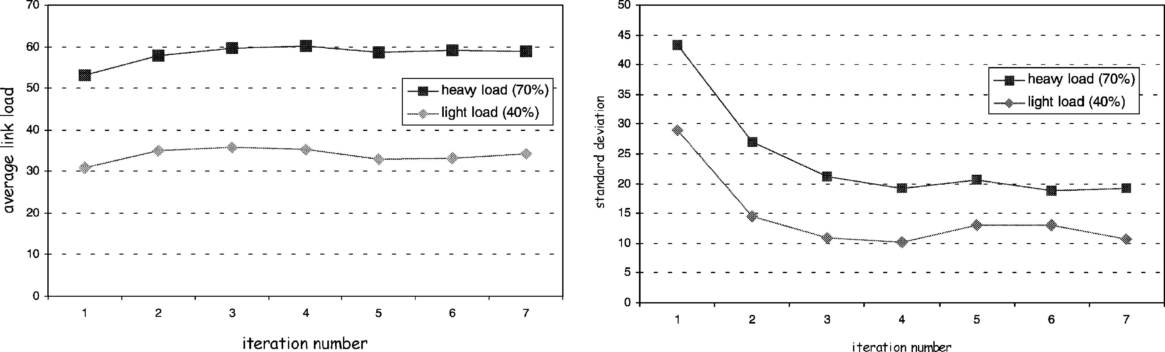
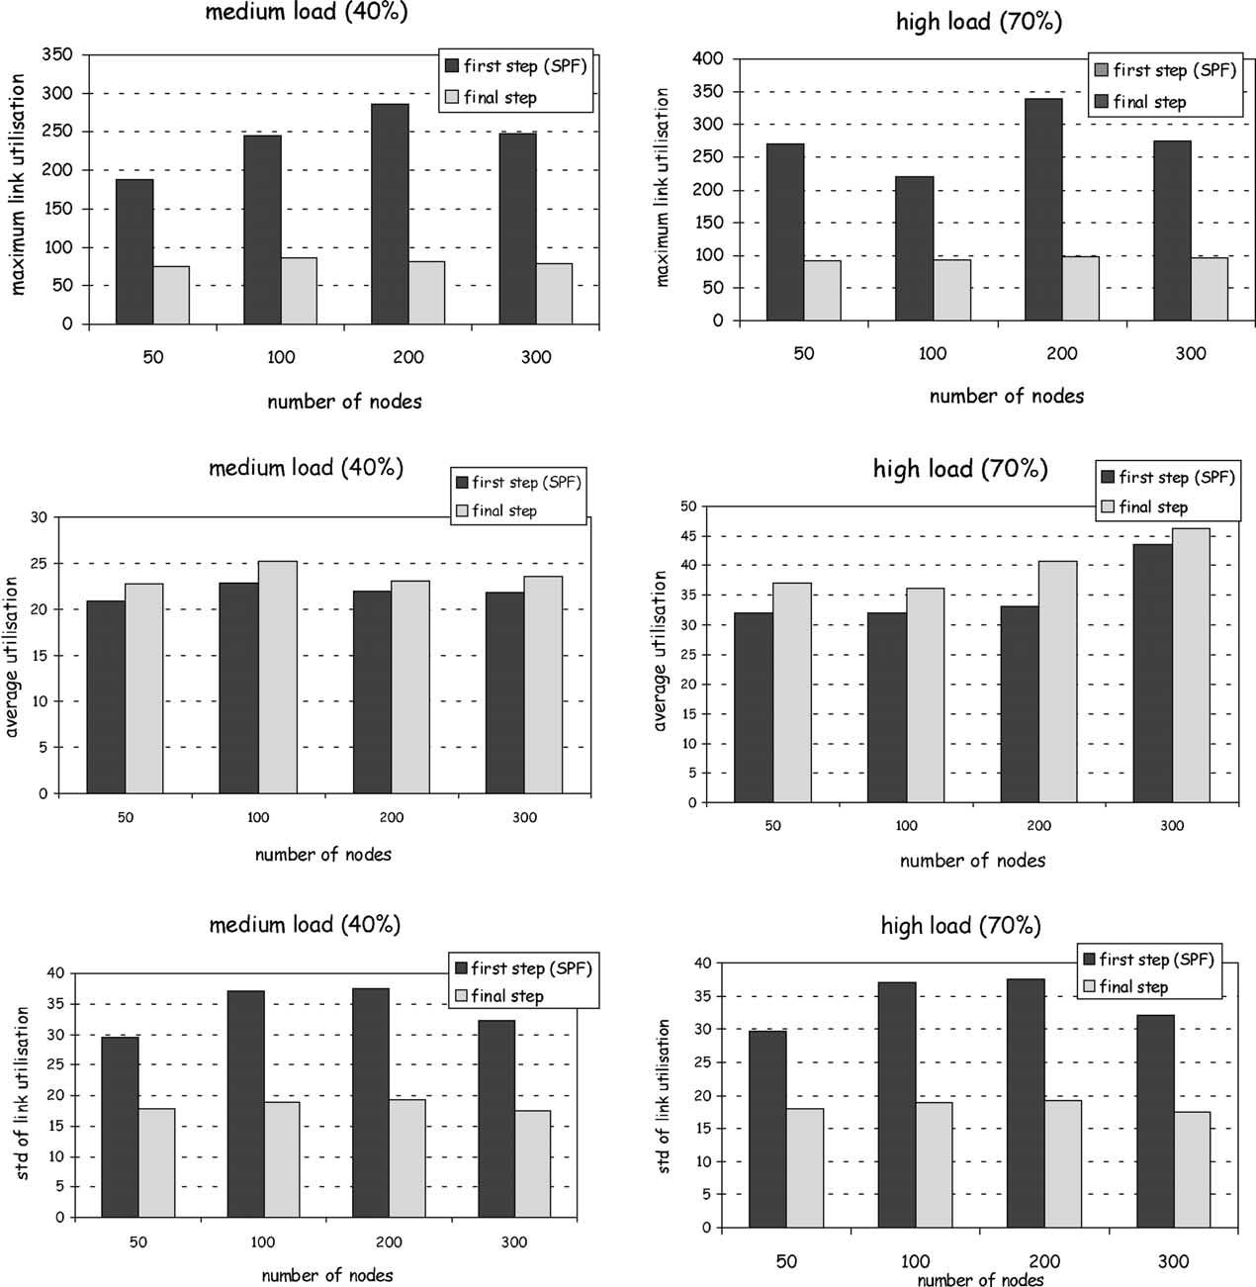

P. Trimintzios et al. / Computer Communications 26 (2003) 845–860

Fig. 7. Average and standard deviation of link load per iteration.

Fig. 8. Maximum, average and standard deviation of link utilisation for various network sizes.

857

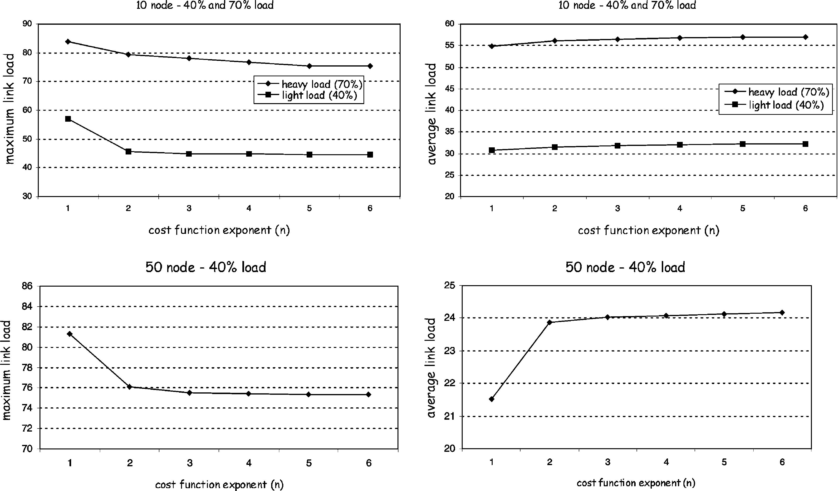
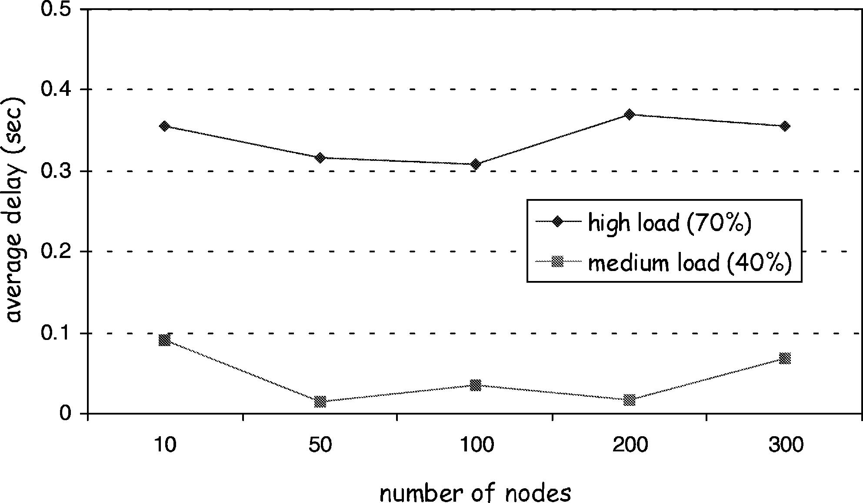

858

P. Trimintzios et al. / Computer Communications 26 (2003) 845–860

Fig. 9. The effect of the exponent for 10 and 50 node network.

increases since minimising the maximum link utilisation
results in solutions with paths having more links. The
solution with n ј 1 means that we only optimise for the
total cost and we do not take into account the maximum link
load objective. We can observe that the reduction of the
maximum link load, and the corresponding increase of the
average link load, is important at the ﬁrst increase of n from
1 to 2, but further increments give only a small difference.
This is a consequence of the fact that we have the hop-count
constraint (see Section 5.3) that limits the number of links
per path and therefore very long paths, which help reducing
the maximum link load, are prohibited. Finally, we can see
that the same behaviour persists for the 10 and the 50 node
networks, as well as all for the larger topologies we used for
experimentation.
We are now going to see the average delay over the
network. We calculated the average delay as a function of
the link utilisation according to the following formula [26]:
1 X x^{h}l

continuing the work presented in this paper we are planning
to have such results from the simulator and from the PC-
based router testbeds we maintain in our laboratories.
Fig. 10 shows the average total delay in seconds
of the solutions provided for the various network sizes
according to the formula given above. The important
observation is that the algorithm manages to keep the
average total delay for all network sizes at about the
same levels. This is particularly important since at
the ﬁrst step we have many links with utilisation more
than 100%, which yields very high (almost inﬁnite) total
average delay. Another important observation is that the
provisioning algorithm results in average delay for
medium and high loaded networks being very close
together, almost proportionally to their relative load
difference. This is an indication that even for high loads

g
l[E
C_{l}2 x^{h}l

where g ј F_{all}=s_{avg}is the average of the total rate of the
incoming packets in the network, F_{all}is the total in expected
rate and s_{avg}is the mean packet size (set to 1 K for our
experiments). The above formula is based on the assump-
tion that each queue (PSC) at each link can be modelled as
M/M/1 queue. Although, this is not always true, we can
only use the qualitative nature of the result and not the
exact values. Note that the only way to ﬁnd the exact
impact on delay and loss is by monitoring the network
after applying the provisioning conﬁguration. As part of

Fig. 10. Average overall network delay.

P. Trimintzios et al. / Computer Communications 26 (2003) 845–860

859

Table 4
Average running times in seconds for the various network sizes

into account the expected trafﬁc demand and QoS
constraints. Using IP networks to transport demanding

10
50
100
200
300
Medium load

0.055
9.761
123.989
529.532
981.175
High load

0.061
10.164
302.079
1002.245
1541.937
trafﬁc will result in lower cost and greater ﬂexibility.

Acknowledgements

The work presented in this paper was partially supported
by the EPSRC/LINK Project GR/M84169 ‘Production of
Broadcast Content in and object-oriented IP-based Network

the provisioning algorithm manages to restrain the level
of increase of average delay.
Finally, in Table 4 we provide the average running times
of the various experiments conducted in this paper. We can
see that even for quite large networks the running times are
acceptable. For example for the 300 nodes networks, for
medium load the running time is about 17 min, and for high
load about 25 min. These times are perfectly acceptable
taking into account the timescale of the provisioning system
operation (see Section 4.1).

7. Conclusions

Supporting demanding applications such as production
network trafﬁc requires dedicated networks with high
switching capacity. In this paper we investigate the
possibility of using common IP-based packet network
infrastructure, with Differentiated Services and MPLS as
the key QoS technologies, in order to support such trafﬁc
with the appropriate Service Level Agreements and network
provisioning.
We propose a management and control system for the
provisioning of such networks, targeting to support
demanding production network oriented Service Level
Agreements while at the same time optimising the use of
network resources. Our model is based on the notion of a
provisioning cycle that comprises a number of forecasting
periods; for each of these we need to apply a different
network conﬁguration. Trafﬁc forecasting is based on the
established SLSs, SLS usage and historical measurement
data. We deﬁned a number of CoS to which we assign
the various SLSs. With this model, adequate provisioning
for the CoSs ensures adequate provisioning for SLSs
as well. Our objectives are then to place the CoS
demands to the network in such a way as to avoid
overloading parts of the network while at the same time
minimising the overall network cost. We devised a non-
linear programming formulation and we proved though
extensive simulation that we achieve our objectives.
In conclusion, we believe it is possible to support
production network trafﬁc through IP networks with
DiffServ and MPLS, as long as the appropriate SLSs are
deﬁned and agreed. They can then be used to calculate
anticipated trafﬁc while the provisioning TE algorithm takes
(PRO-NET)’, and the EU IST Project IST-1999-11253
‘Trafﬁc Engineering for Quality of Service in the Internet at
Large (TEQUILA)’. The authors would like to thank their
project partners for the fruitful discussions while forming
the ideas presented in this paper and the anonymous
reviewers for their useful suggestions to improve the quality
of presentation of this work.

References

[1] S. Blake, D. Black, M. Carlson, E. Davies, Z. Wang, W. Weiss, An
architecture for differentiated services, IETF Informational RFC-2475
December (1998).
[2] E. Rosen, A. Viswanathan, R. Callon, Multiprotocol label switch-
ing architecture, IETF Standards Track RFC-3031 January (2001).
[3] D. Awduche, J. Malcolm, J. Agogbua, M. O’Dell, J. McManus,
Requirements for trafﬁc engineering over MPLS, IETF Informational
RFC-2702 September (1999).
[4] D. Awduche, A. Chiu, A. Elwalid, I. Widjaja, X. Xiao, Overview and
principles of Internet trafﬁc engineering, IETF Informational RFC-
3272 May (2002).
[5] F. Le Faucheur, W. Lai, Requirements for support of Diff-Serv-aware
MPLS trafﬁc engineering, IETF Internet draft June (2002) kietf-tewg-
diff-te-reqts-05.txtl, in press.
[6] A. Feldmann, J. Rexford, IP network conﬁguration for intradomain
trafﬁc engineering, IEEE Network Magazine 15 (5) (2001) 46 – 57.
[7] P. Aukia, M. Kodialam, P.V. Koppol, T.V. Lakshman, nH. Sarin, B.
Suter, RATES: a server for MPLS trafﬁc engineering, IEEE Network
Magazine 14 (2) (2000) 34 – 41.
[8] B. Fortz, M. Thorup, Internet trafﬁc engineering by optimising
{OSPF} weights, Proceedings of IEEE INFOCOM 2000,Tel Aviv,
Israel March (2000) 519 – 528.
[9] M. Kodialam, T.V. Lakshman, Minimum interference routing with
applications to trafﬁc engineering, Proceedings of IEEE INFO-
COM2000, Israel March (2000) 884 – 893.
[10] R.K. Ahuja, T.L. Magnanti, J.B. Orlin, Network Flows: Theory,
Algorithms and Applications, Prentice Hall, Englewood Cliffs, NJ,
1993.
[11] D. Mitra, K.G. Ramakrishnan, A case study of multiservice, multi-
priority trafﬁc engineering design for data networks, Proceedings of
IEEE GLOBECOM 99, Rio de Janeiro December (1999) 1087 – 1093.
[12] D. Mitra, J.A. Morrison, K.G. Ramakrishnan, Virtual private
networks: joint resource allocation and routing design, Proceedings
of IEEE INFOCOM 99, New York, USA March (1999).
[13] F. Poppe, S.V. den Bosch, P.L. Valle-Poussin, H.V. Hove, H. De Neve
and G.H. Petit, Choosing the objectives for trafﬁc engineering in IP
backbone networks based on quality-of-service requirements, Pro-
ceedings of the First International workshop on Quality of Future
Internet Services (QofIS’00), Berlin, Germany September (2000)
129 – 140.
[14] S. Suri, M. Waldvogel, P.R. Warkhede, Proﬁle-based routing: a new
framework for MPLS trafﬁc engineering, Proceedings of the Second

860

P. Trimintzios et al. / Computer Communications 26 (2003) 845–860

International Workshop on Quality of future Internet Services differentiated services in MPLS-based networks, IEEE Communi-
(QofIS’01), Portugal September (2001) 138 – 157. cations Magazine 39 (5) (2001) 80 – 88.

[15] Z. Wang, Y. Wang, L. Zhang, Internet trafﬁc engineering without full
mesh overlaying, Proceedings of IEEE INFOCOM, Alaska April
(2001).
[16] Y. Breitbart, M. Garofalakis, A. Kumar, R. Rastogi, Optimal
conﬁguration of OSPF aggregates, Proceedings of IEEE INFOCOM,
New York, USA June (2002).
[17] S. Chen, K. Nahrstedt, An overview of quality-of-service routing for
the next generation high-speed networks: problems and solutions,
IEEE Network Magazine, Special Issue on Transmission and
Distribution of Digital Video 12 (6) (1998) 64 – 79.
[18] A. Elwalid, C. Jin, S.H. Low, I. Widjaja, MATE: MPLS adaptive
trafﬁc engineering, Proceedings of IEEE INFOCOM2001, Alaska,
USA April (2001) 1300 – 1309.
[19] Z. Cao, Z. Wang, E. Zegura, Performance of hashing-based schemes
for Internet load balancing, Proceedings of IEEE INFOCOM 2000,
Tel Aviv, Israel March (2000) 332 – 341.
[20] D. Grossman, New terminology and clariﬁcations for Diffserv, IETF
Informational RFC-3260 April (2002).
[21] P. Trimintzios, G. Pavlou, I. Andrikopoulos, Providing trafﬁc
engineering capabilities in IP networks using logical paths, Eighth
IFIP Workshop on Performance Modelling and Evaluation of ATM
and IP Networks (IFPM ATM and IP 2000), Ilkey, UK July (2000).
[22] P. Trimintzios, I. Andrikopoulos, G. Pavlou, P. Flegkas, D. Grifﬁn,
P. Georgatsos, D. Goderis, Y. T’Joens, L. Georgiadis, C. Jacquenet, R.
Egan, A management and control architecture for providing IP
[23] T. Li, Y. Rekhter, Provider architecture for differentiated services and
trafﬁc engineering (PASTE), IETF Informational RFC-2430 October
(1998).
[24] F. Le Faucheur, L. Wu, B. Davie, S. Davari, P. Vaananen, R. Krishnan,
P. Cheval, J. Heinanen, Multi-protocol label switching (MPLS)
support for differentiated services, IETF Standards Track RFC-3270
May (2002).
[25] P. Flegkas, P. Trimintzios, G. Pavlou, A policy-based management
system for differentiated services networks, IEEE Network Magazine,
Special Issue on Policy-Based Networking 28 (2) (2002) 50 – 56.
In press.
[26] D. Bertsekas, R. Gallager, Data Networks, Prentice Hall, Englewood
Cliffs, NJ, 1992.
[27] Z. Wang, J. Crowcroft, Quality of service routing for supporting
multimedia applications, IEEE Journal of Selected Areas in
Communications (JSAC) 14 (7) (1996) 1228 – 1234.
[28] D. Bertsekas, Nonlinear Programming, second ed., Athena Scientiﬁc,
1999.
[29] D. Eppstein, Finding k-shortest paths, SIAM Journal on Computing 28
(2) (1998) 652 – 673.
[30] E.W. Dijkstra, A note on two problems in connection with graphs,
Numerische Mathematik 1 (1959) 269 – 271.
[31] E.W. Zegura, K.L. Calvert, S. Bhattacharjee, How to model an
Internetwork, Proceedings of IEEE INFOCOM 96, San Francisco 2
(1996) 594 – 602.

